Solution to Activity 3 – Modify an existing table

The solution to this activity is

1. You will have opened a new Query tab
2. Entered the following SQL statement into the query tab

ALTER TABLE `clubevents`

ADD CONSTRAINT `FK_Clubevents_EventType`

FOREIGN KEY (`EventType`) REFERENCES `EventType`(`ID`);

1. Execute the SQL by clicking the lightning bolt icon.

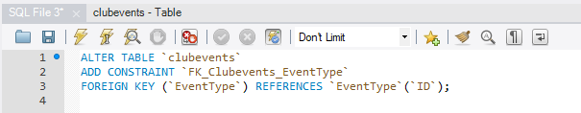

Figure 3.31 SQL Code and Lightning Bolt icon to run it

1. Refreshed the SCHEMA panel and check the Foreign Key was created